**CPT 540 Homework 3**

Question 1

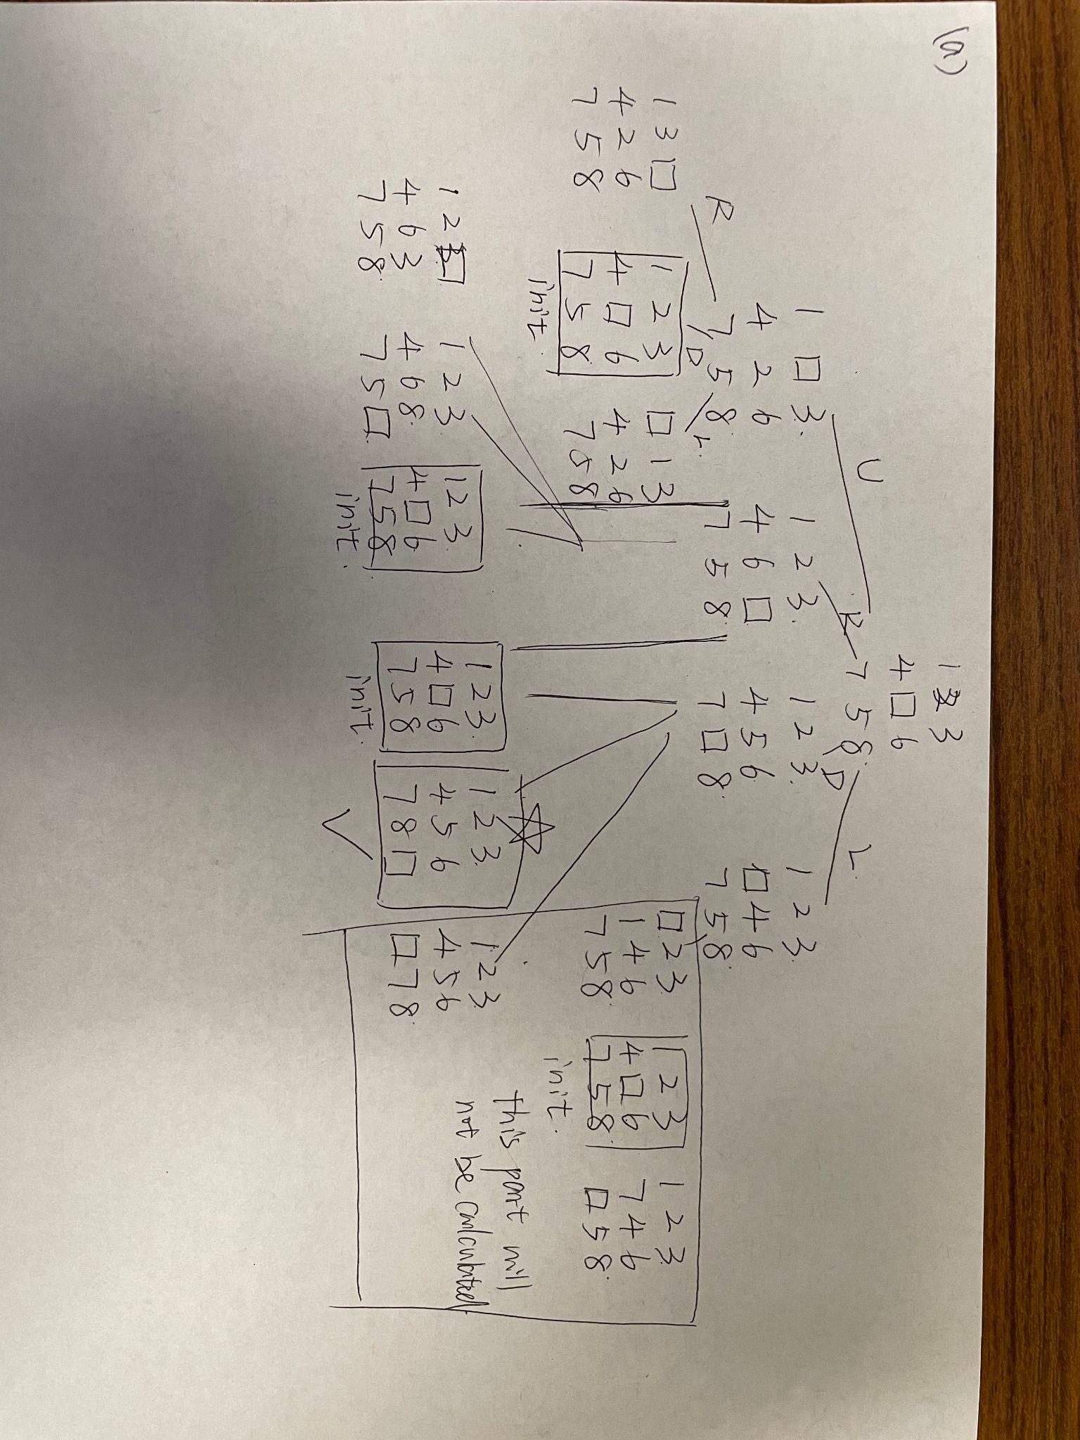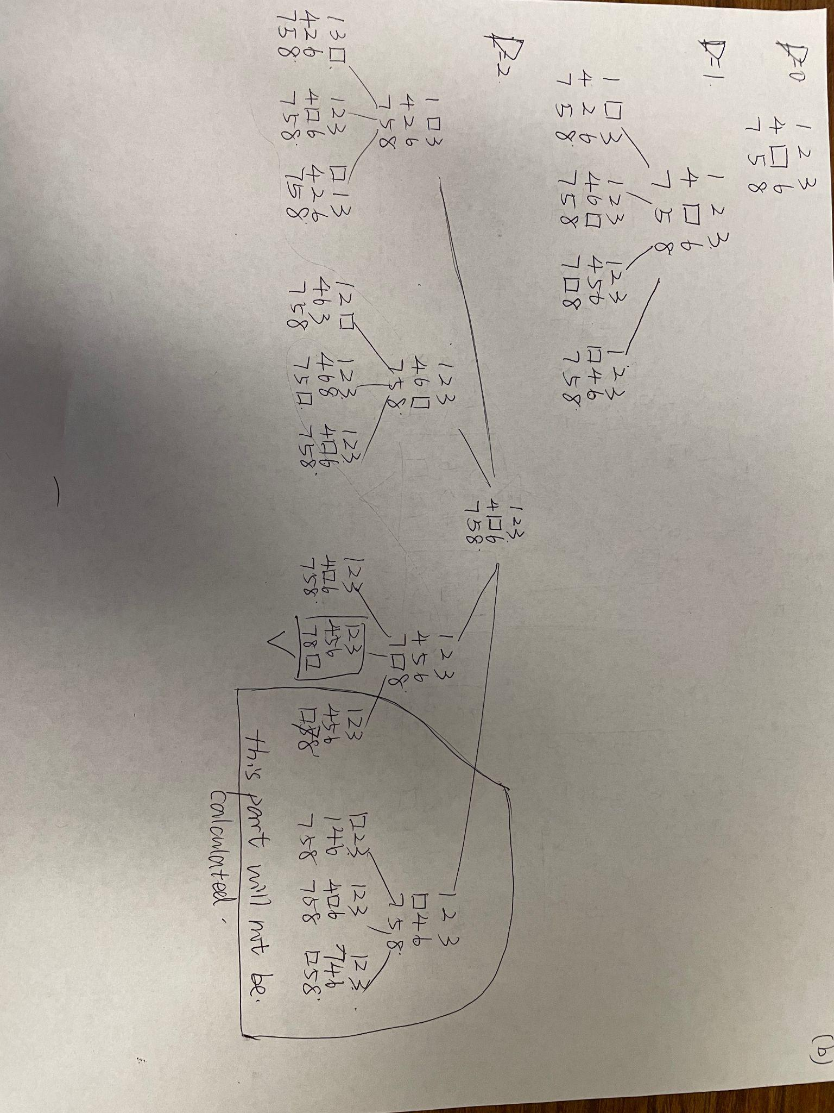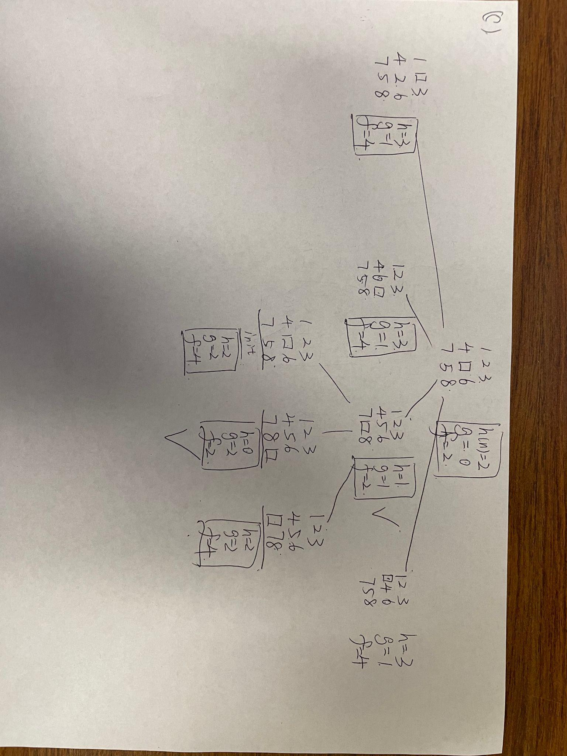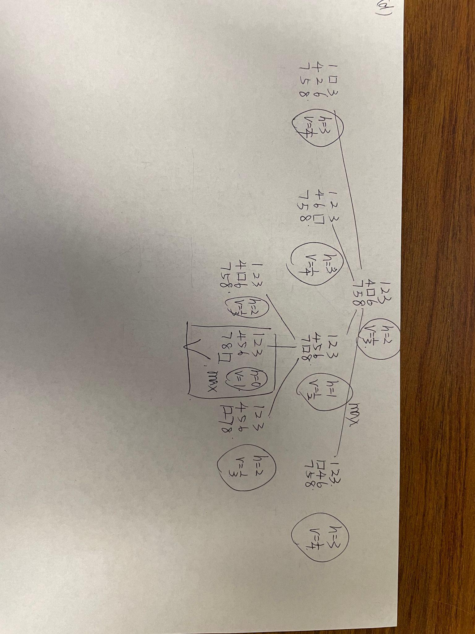

Question 3

So, for the first one, it works as the h-function can be negative (the distance cannot be negative, but functions can). And when it comes up to the requirement (less or equal to the actual cost), the result will be the same.

For the second one, it cannot work. Because if we add one each time for calculating, the minimum cost will be larger than the actual cost.